

**PAPER TITLE: Impact of Capital Restructuring On Business**

**Term Paper Submitted to the Department of Commerce and Management,**

**St. Xavier’s University, Kolkata,**

**In partial fulfilment for the Degree of Bachelors of Management Studies**

**By**

**Sandipan Das**

**(Registration No. XK01-1112-0465-18)**

**Under the supervision of Prof. Sudipta Dey**

**Department of Department of Commerce and Management,**

**St. Xavier’s University, Kolkata,**

**Action Area IIIB, P.S. – New Town, Kolkata – 700160**

**CERTIFICATE**

This is to certify that Mr. / Ms. Sandipan Das , student of Bachelors of Management Studies, has carried out this Term Paper titled Impact of capital restructuring on business under the supervision and guidance of Prof. Sudipta De, in the Department of Commerce and Management, St.Xavier’s University, Kolkata, India. The work submitted is original to the best of our knowledge and has not been carried out elsewhere in any other University or Institute.

(Signature with Stamp) (Signature with Stamp)

Prof. Sudipta De Dr. Somak Maitra

(Supervisor) (Dean of Commerce and Management)

Department of Commerce and Management St. Xavier’s University, Kolkata.

St. Xavier’s University, Kolkata. Kolkata – 700160, India.

**Department/Course: BMS**

**Semester : 6**

**Paper Code : BMHRCC641J**

**Name of Student :Sandipan Das**

**Roll No. :117**

**Date of submission :**

**Declaration by the Student**

I affirm that, to the best of my knowledge, I have identified all my sources and that no part of my Dissertation Paper contents any unacknowledged material.

Signature of Student (with date)

Kolkata – 700160, India.

*ACKNOWLEDGEMENT:*

The achievement and ultimate result of this venture required a ton of direction and help from numerous individuals and I'm very advantaged to have this up and down the finishing of my undertaking. All that I have done is simply because of such oversight and help and I would not neglect to say thanks to them.

I regard and say thanks to Prof. Sudipta Dey for giving me a chance to accomplish the undertaking work in St. Xavier's University and giving us all help and direction which made me complete the undertaking appropriately. I'm incredibly grateful to him for offering a particularly pleasant help and direction.

I again owe my profound appreciation to my venture manage Prof. Dr.Sudipta Dey, who took unmistakable fascination on my venture work and guided me from the beginning, till the finishing of my task work by giving all the fundamental data to building up a decent framework.

I'm grateful to and sufficiently lucky to get steady consolation, backing and direction from all Showing staffs of Business and The executives Office which helped me in effectively finishing my task work.

Table of Contents

Sl. No. Topic Page no.

|  |  |  |
| --- | --- | --- |
| 1. | Introduction | 1 |
| 2. | Background | 2 |
| 3. | Conceptual Framework | 3 |
| 4. | Chapter 1 Review of Literature | 9 |
| 5. | Chapter 2 Provides objectives and needs of the study | 15 |
| 6. | Chapter 3 different methods , tools and techniques used in the study | 17 |
| 7. | Chapter 4 Data analysis and findings of the study | 21 |
| 8. | Conclusion and recommendations | 30 |
| 9. | Bibliography | 31 |
|  |  |  |

*Executive Summary*

As of late, restructuring has become a higher need for organizations scrambling to change, endure and flourish in an intense financial environment. Top HR experts reacting to a 2003 HRI review appraised corporate restructuring as 21st among 120 human administration issues, up from 48th only two years

prior.

The most generally utilized restructuring techniques incorporate vital collusions, re evaluating, scaling back and cutbacks. Seaward rethinking, specifically, has arisen as a developing yet questionable.

Capital restructuring may occur because of an important downfall in the general deals due to the unfriendly financial atmosphere. Here, the corporate element may change the design of the value obligation adjusting plan, the value possessions, and cross brief delay. This is done to support the market and the productivity of the organization.

.

IMPACT OF CAPITAL RESTRUCTURING ON BUSINESS PERFORMANCE OF INDIAN COMPANIES

INTRODUCTION

Markets and economies today are continually evolving. Associations now days are tried with really changing external genuine elements to help and create and truly improve financial backer regard in the more expanded term. As various abundance move from seasons of high improvement to coordinate/upheld advancement (read China, India); Associations are growing expected to relook their capital development from a high commitment circumstance to an upheld agreement among commitment and worth to enhance financial backer regard.

Associations enter various stages in their everyday presence cycle – from high improvement periods, to seasons of steadfastness and the need to help specific level of errands and seasons of monetary trouble.

Capital rebuilding is a device that a consistently expanding number of associations are accepting to course address a plunging bearing of decreasing results. The course core being to improve financial backer regard.

Capital rebuilding takes various designs and can be applied ward on the necessities of the Association and the stage in which it gets itself.

The climb in weakness and changing business environment has achieved development in capital rebuilding cases in the new years. As found in the chart under capital upgrading is on rising.

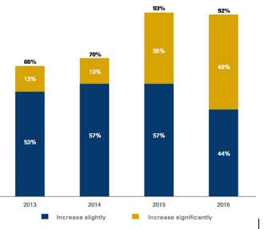

As per the business word reference: Modifying or changing the capital design of an organization because of the changing industry conditions, or as an approach to finance the organization's advancement masterminds.

The requirement for a capital restructuring may emerge on the grounds that any of the accompanying:

1.Extending the business

2.Cost decrease

3.Improving investor esteem

4.Improving debt equity ratio

5.Conquering unfavorable monetary troubles

The redesigning of basically alludes to overhauling the capital construction of the Organization. The center target to remember – the movement should bring about improving investor esteem.

*Background of the study*

In prior years, India was a profoundly controlled economy. In spite of the fact that Government investment was overpowering, the economy was controlled in a concentrated path by Government support and mediation. As such, economy was shut as financial powers, for example, request and supply were not permitted to have a fullfledged freedom to run the market. There was no extent of realignments and everything was controlled. In such a situation, the extension and method of Corporate Restructuring were exceptionally constrained because of prohibitive government approaches and inflexible administrative system.

These limitations stayed stylish, for all intents and purposes, for more than two decades. These, in any case, demonstrated incongruent with the financial framework in keeping pace with the worldwide monetary improvements if the goal of quicker monetary development were to be accomplished. The Government needed to audit its whole approach system and under the financial progression estimates expelled the above limitations by discarding the pertinent areas and arrangements.

With the growing competitiveness in the market and the economy, going towards globalization, the corporate modifying practices are depended upon to occur at a significantly greater degree than at whatever point previously. Corporate Rebuilding accept a critical occupation in engaging dares to achieve economies of scale, overall earnestness, right size, and an enormous gathering of various benefits including abatement of cost of errands and association.

*Conceptual framework*

Capital Restructuring is basically motivated at changing the ratio of equity and debt in the company’s capital structure. It can be a result of crisis. It may be changing of the conditions in the market or hostile takeover of Bid.

The scope of this study is:

1. To grasp the overhaul of the capital cycle

2 .Inspect the current and the past accomplishment and frustration stories in improving financial backer regard

3 . Explaining the ordinary slip-ups of the cycle and exhortation on how corporate organization needs to avoid them.

Research issue under study

A.Capital restructuring through demergers

Makes basic financial backer regard especially in case of totals when done precisely, as it open offer worth increases. The development is in like manner knows as spin off. It is particularly beneficial when negative helpful energies exist or diseconomies of scale exist in an association/total (It moreover sorts out some way to convey greater clearness of psyche to confine business and licenses them to restrict themselves against relevant endeavors.

B.Capital restructuring through share repurchase

Most normally utilized other option, regularly yields helpless returns. An organization ordinarily utilizes an offer repurchase course when it has excess money. Excess money is applied for repurchasing its own offers and accordingly decreasing the absolute number of extraordinary offers, which subsequently brings about a higher profit for each offer (EPS). An offer repurchase may likewise help deflect a threatening takeover offer.

C. Capital restructuring through debt reduction

Experiences unavoidable losses and ought to be viewed as simply after cautious examination. An obligation restructuring is particularly reasonable when an Organization experiences income issues or battles to support interest installments/obligation reimbursements. Obligation restructuring is moderately more affordable than a liquidation insurance. It assists upgrade with liquidating streams accessible to investors, improves the obligation value proportion and cuts down the interest cost.

When does need for capital restructuring arise?

Organizations enter different stages in their day to day existence cycle – from times of high development, to times of soundness which expect Organizations to support certain degree of activities; and to times of monetary difficulty.

What are the types of capital restructuring?

Capital restructuring takes a few structures, in our examination we have attempted to three significant three significant options that have been utilized by different organizations with fluctuating levels of progress:

1. Demergers
2. Share buyback's
3. Debt reduction resulting in better debt-equity multiples

Following stock: In situations where organizations have at least two different business, out of which one business provides info regrading a quickly developing business, the Organization may give a following stock. The stock permits the quickly developing business to be esteemed independently and will bring about a higher valuation for the Organization by and large.

A following stock is liked to a side project or an auction as this permits the administration to have authority over the specialty unit just as use advantages of collaborations and regular capacities with other specialty units.

How is financial restructuring achievement estimated?

Economic value added (EVA)

1.Surplus produced from operating activities well beyond cost of capital

2. Monetary worth added (EVA) is a superior marker of business execution contrasted with the profit from venture (return on initial capital investment)

3. Expansion in return for capital invested isn't really useful for investors, though increment EVA is consistently certain for investor esteem

Financial benefit is a preferable measure over bookkeeping productivity

1.Financial benefit is estimated through inside pace of return (IRR) of the free incomes

What are the regular traps to maintain a strategic distance from?

Corporate restructuring infers monetary changes, it isn't just about renegotiating or modifying the terms and states of the obligation, it is essential to comprehend the fundamental reasons for the liquidity issue. A fruitful corporate restructuring is an exhausting errand and takes up a lot of senior administration's time.

The investigation distinguishes and explains the basic entanglements:

Restructuring implies monetary changes yet that isn't all, there are different perspectives identified with it like resource the executives, improving the extent of firm and capital construction.

Financial productivity that is estimated by the inward pace of return of FCF to investor should be picked over bookkeeping benefit that is estimated with return on value.

Planning is a fundamental prior to beginning an exchange. The administrators ought to be set up regarding what ensure the organization can offer, how the renegotiating will be disseminated, what are the conditions and the limits that the certifications are exposed to.

There must be reliable arrangement to improve the organization's liquidity, monetary arranging must be steady, obligation exchange and restructuring ought not be likened, and so on

Past restructuring stories

Different Cases:

Arvind Factories Case:

The paper has attempted to dissect the accomplishment of a corporate restructuring program dependent on a contextual investigation approach. In the paper, the creators have portrayed the instance of Arvind Plants, a main material Organization in India, which experienced restructuring exercise.

Realities of the case –

Arvind Plants put resources into a monstrous extension of its denim office in the 1990's, albeit different makers were differentiating away from denim textures because of lull popular. Arvind Plants had subsidized this extension through critical obligation on its books.

The Organization ran into profound monetary difficulty and couldn't support its obligation and interest trouble.

At last it revealed a misfortune in the year 2000 as against benefits up to 1999.

Seeing the mistake of its expansion, the Association went into a commitment rebuilding activity in Feb 2001. By mid-2001 the Association got support for commitment rebuilding from bigger piece of its advance experts with a couple of banks taking significant cutoff points on head and premium, and now and again banks assented to 5 to long haul's rollover period for premium. The rebuilding diminished the Association's top notch weight significantly. The Association also transformed into the important Indian association to remake its entire commitment in one go. Post the rebuilding, the Association returned to benefits in the year 2002 with a net advantage of Rs 10 crores in the primary quarter of 2002, tending to a re-appearance of advantages following 3 years.

Essar Contextual investigation:

Essar Steel is a subtly held endeavor of the Ruia family in India. The component has gathered commitment of up to Rs 40,000 crores and has entered in to gouge rebuilding plans with the moneylenders.

Post the rebuilding, the stake of the Ruia's in the Association would reduce to 40%. State Bank of India, would take over 34% of the shareholding by changing over piece of its commitments into esteem. While Ruia's will offer 26% of the Association to private worth monetary patron Farallon Capital for Rs. 1,700 crores.

The rebuilding tends to a basic accomplishment for the financial backer who have for since a long time prior been pushing for one. As of now the lenders are working on a rebuilding plan and the cut they intend to take on their openings. Also, the credit expert is drawing up a corporate organization framework for extending their control over the Association. The change to esteem gives an enormous say to the lenders in any destiny of the Association.

For the banks, it moreover infers that they may really dispense with it from the NPA later on which would be an immense lift to their resource reports.

This worth arrangement returns on the of another huge arrangement which the Ruia's made – offer of 98% stake in Essar Oil to Rosneft, Russia for USD 13 billion which paid off past responsibilities by the larger part.

*Chapter Planning*

**Chapter 1-** It provides info regarding the initial stage of the study, the background of the study, the conceptual research and the outlines of the chapter.

Chapter 2 – It provides the literature review of the study i.e what are the past research made on this particular field.

Chapter 3 - It outlines the objectives of the study and the need of the study – the proclamation of the issue.

Chapter 4- It shows that what are the different methods and tools and techniques used to read the data.

Chapter 5 – It refers to the data analysis and findings by using techniques like demerger, Share buyback and debt restructuring.

Chapter 6- It gives the conclusion and recommendations based on the study.

Chapter7 – It outlines certain limitations involved in the study conducted.

*Review of Literature*

1. Dittmar, A. (2003) overviewed about the decisions taken by the firm regarding their fundamental capital modify in a corporate side ventures. The effort was put to recognize whether there stays an ideal or target capital construction of a firm and how it picks its impact to achieve that target. Notwithstanding, the assessment was left reluctant on account of the deterrents achieved by the deviations from the affiliation's target impact extent because of their working and budgetary decisions. Muller, M. (2003) has recognized the five critical determinants to pick the ideal divestiture strategies. He evaluated different strategies for disaggregation to make financial backers worth and its benefits similarly as its shortcomings. He refered to a gathering that "on a typical parent associations and reinforcements beat the market, particularly after side undertakings and worth patterns. Following stocks perform close by the market".

2.M Chandra Shekar, Mohd Akbar Ali Khan (2019) They have shown that the Share Repurchases or Buyback of shares is the repurchase of its own shares by an organization. The buyback of shares is progressively mainstream in nations like the US, UK, Hong Kong, and India. The buyback of shares is permitted in India because of the Buyback of Protections Guideline Act 1998. From that point on many recorded Indian Private and Public organizations made the declaration of various share buyback programs. Indeed, these buyback programs have become famous corporate activity, particularly over the most recent five years. This paper led the investigation to survey the writing accessible on share buybacks for the time of 1998-2016.

3. Leena Afroz Mostofa Chowdhury, Tarek Rana, Mahmuda Akter, Mahfuzul Hoque (2018) They have attempted to explore the effect of scholarly capital (IC) on monetary execution and, accordingly, to give encounters into its impact on emerging economies.

Plan/methodology/approach Data were assembled from 34 material firms in Bangladesh some place in the scope of 2013 and 2017. The IC adequacy, through regard added scholarly coefficient (VAIC) model, and its impact on monetary execution, through return on assets (ROA), return on worth and asset turnover (ATO), was dissected using illuminating experiences and distinctive relapse systems. The examination relies upon auxiliary data got from yearly reports.

4. Klock; and Mansi (2011) have analyzed the pretended by the parent's rationale in endeavor a cut out and tracked down that the post Initial public offering guardian proprietorship altogether influences the securing probability and the degree of obtaining premium.

5. Sumathi Kumaraswamy, Rabab Ebrahim, Hussain Nasser (2019) They have showed how EN Corporate restructuring has gotten one of the critical solution for firms to improve their financial performance, acquire upper hand and industry strength. This paper intends to inspect the impact of corporate restructuring on firm performance of the GCC firms utilizing profitability, liquidity and influence measures. The biggest consolidations and acquisition bargains in GCC through a long time from 2004 to 2017 were chosen for this investigation. Customary Least Square Regression technique with sham factors was utilized to analyze the impact of corporate restructuring. The experimental outcomes showed that profitability pointers return on resources and net profit edge uncovered an adverse consequence of consolidations and acquisitions (M&A) on the example firms, however the outcomes are not genuinely critical. The regression results confirmed that M&A bargains irrelevantly affected the influence position of the GCC firms. If there should be an occurrence of firm liquidity, a huge adverse consequence was knowledgeable about the post M&A periods. The results of this examination suggest that there is no reason that consistently M&A bargains bring synergic impact on the association's profitability.

6.Hiral Vyas, R K Patel (2018) explained the way toward adjusting the wellsprings of resources by the administration to accomplish the ideal objective of the business. The paper is an endeavor to comprehend one such broadly acknowledged instrument of rebuilding to be specific, buyback of offers alongside strategies and components that thought processes the board to choose this device. The paper is an endeavor towards the confirmation of the genuine subtleties in lawful part of buyback program in India to protect the premium of the partners and limiting the self-advancement of the supervisors. Further investigation of the subject can be done by taking the monetary information of the organizations picked buyback of offers to check the thing if investors' abundance creation object is served.

7.

Puja Aggarwal, Sonia Garg (2019) examined the effect of spin-off declarations on the parent association's offer costs. Additionally, it is examined that during which period the declaration impacts the offer costs altogether consequently influencing the investor riches.

Plan/system/approach An example of 76 Indian firms has been removed which reported the twist from their at least one divisions during 2010–2011 to 2015–2016. The authors have utilized the occasion study procedure with an occasion window time of −35 to +35. Assessment window of 256 (−290, −35) days is considered in the examination. S&P BSE 500 is utilized as a market list.

Discoveries -The authors found that side projects affect the offer costs of the parent firm. The authors likewise tracked down that normal unusual return (AAR) of the multitude of 76 organizations taken together have been most noteworthy on day 0 and the aggregate AAR is most elevated for day.

8. Sonia Singh, Subhankar Das (2018) This investigation was led to evaluate the effect of consolidation and procurement exercises on the exhibition of Banks in India. The paper surveys the patterns in M&A's in Indian banking and afterward effect of M&A's has been concentrated in three driving banks of India. The examination covers the space of execution assessment of M&A's in Indian financial area during the time frame pre and post time of six years of Consolidation and Obtaining movement. The paper considered the post-consolidation monetary execution of combined manages an account with the assistance of monetary boundaries like, Net Overall revenue, working Overall revenue, return on Capital Utilized, Return on Value, profit per share, capital sufficiency proportion, profit per share and so on The discoveries showed that techniques and approaches in procedural, physical and socio-social settings were vital components in the post-consolidation and procurement measure. Moreover, the subjective effects of the post M&A exercises like bookkeeping reports, market valuations and key.

9.Laura Horn (2012) have broke down on the essentially political nature of corporate organization rule and battles that the difference in corporate organization rule is significant for a more broad political errand of monetary modifying and marketmaking in the EU and showed that how association law has gotten continuously based on the advantages of financial backers, while worker rights have been relegated to the space of social methodologies and work law. Desai; Klock; and Mansi (2011) have assessed the imagined by the parent's perspective in try a cut out and found that the post Initial public offering guardian ownership by and large impacts the obtainment likelihood and the level of getting premium. Zahid and Shah (2011) have communicated that associations from non-mechanical countries have started to buy out associations of made countries as their economies are improving appeared differently in relation to the made world on account of insignificant exertion of creation. Indian and Chinese money chiefs are the most powerful stood out from rest in such way.

10. Vishal Mehta Vandana Gandhi, Prashant Chhajer (2018) showed that intensity and upper hands have become the popular expressions, for corporate all throughout the planet. Corporate rebuilding has acquired significant significance everywhere on the world in view of extreme rivalry, globalization and innovative changes and in this setting consolidations and acquisitions (M&A) are in effect progressively utilized the world over, for improving seriousness of organizations through acquiring more prominent piece of the pie, widening the portfolio to decrease business hazard, for entering new business sectors and topographies, and exploiting economies of scale and so on Consolidations are significant corporate procedure activities that, in addition to other things, help the firm in outside development and give it upper hand. This territory has generated a tremendous measure of writing over the past 50 years, particularly in the created economies of the world. India also has been seeing a development in the new time.

11. Urvashi Varma, Harjit Singh, Alka Munjal (2018) In this examination they have broke down the corporate activities, for example, the" free money" strategy, profit dissemination, change in capital design and lower productivity while choosing deciphering the purpose behind these 'delicate offer buyback'and 'open market buyback'offers between January 2004 to December 2017. The examination utilizes an example of ninety open market repurchasing organizations with a comparative number of non-repurchasing organizations and of 54 delicate buyback organizations with 54 non-repurchasing organizations in a similar industry having comparable market capitalization and recorded on Bombay stock trade (BSE). To examine the drivers of open market buyback and delicate offer buyback in India, a Tobit relapse investigation has been utilized. The examination presumes that 'Delicate offer buyback'is utilized all the more prevalently for capital construction amendments, while on account of open market repurchase in India, profit replacement and capital design revision go about as the key drivers. Regardless of whether 'size of the organizations' have any huge effect or not, study uncovered positive effect.

12.H. Kent Dough puncher and Halil Kiymaz , (2014) in their book on 'The Specialty of Capital Restructuring: Making investor esteem through Consolidations and Acquisitions' characterize restructuring as "a demonstration of incompletely destroying or in any case rearranging an Organization to make it more productive". The book extensively classes restructuring in to structures – physical restructuring and capital restructuring – which alludes to adjustment in the capital construction

13.In the Dr. Bernadette D'silva and Mrs. Annie Beena (2013),Joseph have depicted the cycle of corporate restructuring as upgrading the Organization. The creators bring up that corporate restructuring is applied dependent on requirements of an association and it constantly varies for each situation. Associations apply restructuring as consolidations, acquisitions just as demergers, while a few organizations use it to complete primary changes in the start to accomplish asset improvement.

An Investigation of Various Methods of Corporate Restructuring by Rakesh Kumar Sharma, the creator has depicted different restructuring strategies, for example, sell-offs, value cut outs, side projects and following stocks. Auction: The examination depicts an auction as a through and through offer of an Organization's auxiliary. Auction are done on the grounds that the auxiliary doesn't frame part of the parent's methodology. Sell-offs are utilized to produce money which is then utilized in the center organizations and to take care of obligation.

Value cut out: To open worth, the parent offers load of an auxiliary in an Initial public offering. It is normally done when one of the auxiliaries is becoming quicker than the rest. Be that as it may, the parent would hold the larger part holding in the auxiliary and furthermore viably its authority over the auxiliary, through regular board individuals and so on, to push through the parent's board business procedure. The movement additionally upgrades the investor estimation of the parent.

Cut outs notwithstanding if not dealt with well may result in to strife between the parent and auxiliary, as the auxiliary currently additionally has obligation towards its public investors.

.

14.Rakshit, D. furthermore, Sujit, G. (2010) made a near money related and operational execution of JK Industries. Here the money related and operational productivity is estimated by looking at the pre demerger and post demerger period with the assistance of the conventional and present day monetary estimating techniques. They found that the organizations' are improving money related and operational effectiveness after the demerger

15.Ansgar Belke , Christian Dreger in their study showed that the government of Greek Budget situation played a greater role in the crisis of the debt in the European boundaries. They showed that calculations based on simulations of the cost of fiscals is huge in European countries.

Dhume and B Ramesh (2011) in their examination showed that common Asset industry in India has

arisen as the most powerful portion of the Indian monetary framework. The business developed

significantly during the most recent couple of years. With the plenty of plans accessible for the financial

backers to pick, it gets fundamental for a retail financial backer to know the exhibition of the shared

assets to settle on an educated choice. In this paper, we have completed the presentation assessment of

open-finished value area common finances utilizing five methodologies of execution measures viz,

Sharpe Proportion, Treynor Proportion, Jensen&#39;s Action, Data Proportion and M-squared measure. The

areas chose with the end goal of the investigation are banking area, FMCG area, framework area,

pharma area and innovation area. Every one of the plans are chosen from the particular areas which

were existing during the time of the examination. The time frame received for the examination is from

first April 2008 to 31st Walk 2011.

16.I.M Pandey (2013) in his examination showed that 122 tions, including Thailand, could convey high and predictable Gross domestic product development rates (7-9% per annum) throughout the following quite a while. Interest for shopper merchandise kept on being solid, with higher customer spending

among the arising working class because of the developing per capita pay. What&#39;s more, Thailand and the district&#39;s developing assembling base, which included cars, electrical apparatuses, and the utilization of plastic as a substitute for common materials, were the principle drivers of plastic utilization. Display 1 recognizes the principle uses of petrochemical items.

TPI effectively took part in the advancement of Thailand&#39;s petrochemical industry. TPI was essential for

the gathering of private financial backers that joined the some time ago state-claimed Petrol Authority

of Thailand and the Thai Government in building up an incorporated homegrown petrochemical

industry, to some degree to exploit locally accessible petroleum gas assets.

17.Kaushik Ghosh (2020) in his examination clarified the job of government in Consolidations and

Acquisitions (M&amp;A) and administration regarding a similar should be re-characterized as M&amp;A acquires

bleeding edge wonders. The paper expects to audit, sum up and talk about different institutional laws in

regards to consolidations and acquisitions (M&amp;A) in India and consequently suggest productive strategy

rules for establishments and directors taking an interest in consolidation and securing bargains. This

paper gives a survey of the Report of the master advisory group on organization law on M&amp;A distributed

by Service of Corporate Issues (MCA). The paper on M&amp;A by MCA has summarized 34 focuses which can

be characterized under five wide angles 1. Construction and Level headed, 2. Execution, 3. Likely

Advantages, 4. Likely Requirements and 5. Proposed Cures. These are additionally dissected in the light

of Construction, Direct and Execution (SCP) worldview.

18.Arun Kumar Gopalaswamy (2013) in his examination observationally researches the conduct of offer

costs around share repurchase declarations by Indian firms utilizing a standard occasion technique. It was seen that there was a huge market response to the repurchase declarations during the declaration time frame viz. the declaration date and the day before it. The market response t perseveres on the main day after the declaration of purchase backs paying little heed to the repurchase components received by the organizations. The examination proposes that the offer costs which recorded a quick decrease preceding the repurchase declaration remained practically steady for a couple of days promptly following the declaration and afterward declined once more, yet at a much more slow speed.

An example like that of the post declaration time frame was likewise seen after the event of genuine

repurchase. This investigation additionally looks at the organizations&#39; decision of repurchase system.

19. Satish Kumar (2017) showed in this paper is to contemplate the situation with concentrates on capital design determinants in the previous 40 years. This paper features the significant holes in the writing on determinants of capital construction and furthermore expects to bring up explicit issues for future exploration.

The conspicuousness of examination is evaluated by contemplating the time of distribution and district, level of financial turn of events, firm size, information assortment strategies, information investigation procedures and hypothetical models of capital design from the chose papers. The survey depends on 167 papers distributed from 1972 to 2013 in different companion checked on diaries. The relationship of determinants of capital construction is investigated with the assistance of meta-examination.

Significant discoveries show an increment of premium in research on determinants of capital design of the organizations situated in developing business sectors.

*Objectives of the study*

1. To get a comprehensive perspective on the capital restructuring measure
2. Comprehend the normally applied strategies for restructuring
3. Survey past progress and disappointment stories and comprehend the drivers for progress and disappointment

4. To comprehend the normal entanglements all the while

5 . At last, to draw inductions from past contextual analyses and close on the effect of restructuring on business execution.

Need for study – Proclamation of Issue

Existing key administration writing focuses on association restructuring and/or harps just on specific parts of monetary restructuring without giving a more all encompassing perspective. As economies move from time of high development/blast period to more supported times of development, present day administrations are continually needed to advance and reexamine plans of action to guarantee more noteworthy concentration and amplify investor esteem.

Henceforth, there is a requirement for a paper that expounds the three significant types of monetary capital restructuring in particular – share repurchase, demergers and obligation decrease. The examination further proceeds to assess the achievement pace of these restructuring measures by assessing past progress and disappointment cases, drawing deductions from these contextual investigations and featuring things that were done effectively and those that were most certainly not. Moreover, the investigation additionally discusses the normal traps in the restructuring cycle and gives counsel on the most proficient method to keep away from such entanglements.

Another significant perspective that we will attempt to cover is estimating the genuine worth addition to investor post the capital restructuring measure. There is a requirement for result to be estimated quantitatively, to make to assess and finish up, regardless of whether capital restructuring brought about any substantial additions to the investors.

Strategies for estimating the result of capital restructuring measure on business execution:

Economic value added (EVA)

Financial worth added is characterized as any overabundance created from working exercises far beyond the expense of capital.

Monetary worth added (EVA) is a superior marker of business execution contrasted with the profit from venture (return for capital invested).

He contended that return on initial capital investment isn't generally viable and justifiable – an expansion in return for capital invested isn't in every case useful for the investors, while an increment in EVA is in every case useful for the investors. Obligation value restructuring is done to build productivity and to improve or reestablish liquidity. Consequently ROCE is an important measure as expressed by rejuvenation partners (2013).

Financial productivity/Inward Pace of Return

Financial productivity is estimated through inward pace of return (IRR) of the free incomes.

*Research Methodology*

1. Background studies- Literature review.
2. Data collection - Sources are annual reports, market info from Reuters and other published data.
3. Analysis- Analysis of success determinants and common pitfalls.
4. Conclusion- Findings and Inferences , final recommendations and conclusion.

The entire exploration can be isolated into four significant stages specifically Foundation Studies, Information Assortment, Examination and End. Foundation contemplates incorporate writing overview identifying with capital redesigning in when all is said in done, significant types of redesigning and studies identifying with estimating the accomplishment of capital restructuring. The writing survey will give the establishment to the exploration wherein holes will be recognized.

The following stage is information assortment which will incorporate sources like yearly report of Organizations when restructuring, securities exchange data and other distributed information.

The Examination stage will incorporate investigation of the gathered information during the past stage with center around estimation of achievement determinants. This stage will close with the deductions drawn from the investigation.

In the last stage, in light of derivations drawn from the past stage, we will feature things that were done effectively and those that were not and the regular entanglements in the restructuring cycle and gives counsel on the best way to dodge such traps.

Speculation

H1 – Capital restructuring as demerger will bring about more noteworthy worth creation for investors

H2 – Capital restructuring as demerger won't bring about more prominent worth creation for investors

H3 – Capital restructuring as obligation decrease will bring about more prominent worth creation for investors

H4 – Capital restructuring as obligation decrease won't bring about more noteworthy worth creation for investors

H5 – Capital restructuring as offer buyback will bring about more noteworthy worth creation for investors

H6 – Capital restructuring as offer buyback won't bring about more noteworthy worth creation for investors

Subsequent to assessing the writing, we have distinguished 2 cases every one of organizations having utilized capital restructuring through demerger, obligation decrease and offer repurchase of effective just as fruitless organizations.

*Data Collection Approach*

Auxiliary sources have been utilized for information assortment by social event monetary data of test organizations when restructuring. The information sources which were utilized for information assortment are as per the following:

• Organization budget summaries from public space

• Securities exchange data from Reuters

• Other distributed factual date: Paper articles, books on restructuring/

Test Determination

The current examination incorporates the three significant procedures of capital restructuring regularly utilized by organizations. While choosing test organizations for our examination, the accompanying focuses were thought of:

Just those organizations have been viewed as which were openly recorded before going into the restructuring exercise, so we have vital information accessible in the public space to dissect the impacts of restructuring on investor esteem creation.

The last example size for the investigation contains 7 organizations across the three generally utilized strategies for capital restructuring as demonstrated in the table underneath.

1.Share Repurchase/ Buyback- GlaxosmithKline , Bajaj Auto

2. Demergers- Dabur India , Bajaj Auto , Tata Chemicals

3.Debt Reduction – Titan Industries , Nirma

Data Analysis Method

The accompanying advances will be continued in leading the examination:

Perusing of the cases to recognize the organizations having gone through restructuring and systems utilized for improving investor esteem.

Picking test organizations in each significant class of restructuring (allude Figure 2: Chose Contextual investigations above).

The logical structure of the investigation will incorporate two significant parts

Economic Value added (EVA) – It is the proportion of an Organization's monetary exhibition. It addresses the overabundance of working benefits of the Organization well beyond its Expense of Capital.

EVA = Net Operating profit after taxes (NOPAT) – Contributed Capital * Weighted average cost of Capital (WACC)

Return on capital utilized (ROCE) – It estimates the Organization's benefit and the proficiency with which the capital is utilized.

ROCE = Earnings before interest and taxes (EBIT)/Capital Utilized

Piece of the overall industry cost of the Organization pre and post restructuring

The examination is relied upon to give knowledge on the effect of capital restructuring on investor abundance. The investigation will be accomplished for each organization independently and afterward be contrasted and organizations embracing comparable type of restructuring all together draw inductions on progress or disappointment of such restructuring.

*Data analysis and findings*

Demerger Case Examination:

On seventeenth May 2007 the overseeing assortment of Bajaj Auto Confined supported an arrangement of demerger of the vehicle and financial organizations ltd. The auto space of Bajaj was its middle competency in this manner they envisioned that the demerger will allow Bajaj Auto confined to center and raise more capital for its middle business. In this arrangement of demerger Bajaj Auto limited was to be renamed as Bajaj Holding and Hypothesis Confined and two new helpers were to be outlined Bajaj Auto Confined and Bajaj Finserv Limited. The vehicles business was moved to Bajaj Auto while the customer cash and insurance associations and wind impact project business was moved to Bajaj Finserv. The current financial backers of the Association were given one offer all of the new Bajaj Auto and Bajaj Finserv for each offer held in the new Bajaj Auto.

With the end goal of the investigation, we have contrasted and EVA pre and post consolidation and drawn deductions accordingly.

|  |  |  |  |  |  |
| --- | --- | --- | --- | --- | --- |
|  | Bajaj Auto Erstwhile company | Bajaj Auto, New | Bajaj Finserve | Bajaj Holding | EVA total |
| EVA | 140.17 | 478.98 | -132.50 | -165.63 | 180.85 |

In January 2003, Dabur India Restricted declared its arrangements to demerge the drugs business into a different organization called Dabur Pharma Restricted, to being more noteworthy concentration to singular organizations After the demerger, Dabur India would zero in on its center organizations like medical care, ayurvedic strengths and individual consideration, though Dabur Pharma would zero in on its pharma abilities – oncology plans and medications. With the end goal of the investigation, we have contrasted and EVA pre-and post-consolidation and drawn derivations thusly .

|  |  |  |  |  |
| --- | --- | --- | --- | --- |
|  | Dabur India Erstwhile | Dabur India , New | Dabur Pharma | Eva Total |
| EVA | 49.08 | 53.33 | -9.29 | 44.04 |

Demerger: Viability

The higher EVA was generally caused as a result of the gigantic worth starting in the Auto business. Auto business' EVA significantly more than the pre-combination composite EVA of the single component Bajaj Finserv and Bajaj Holding declared negative EVA undeniably showing defenseless use of capital. As a rule, the demerger of Bajaj Auto was regard accretive to the financial backers.

.Lower hard and fast EVA was achieved by the clinical associations – which showed that capital was deficiently applied in the pharma business (a more capital concentrated business), while the FMCG business became more acquainted with how to open financial backer regard.

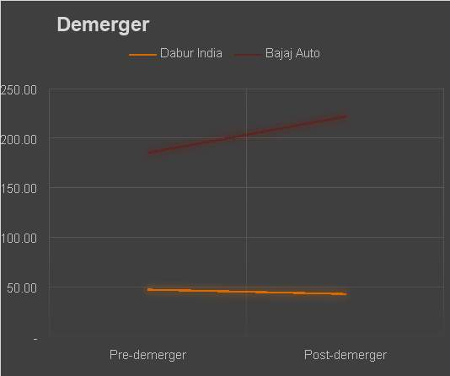

Demerger of Consumer Segment from Tata Chemicals: How beneficial is it?

An outline of how the plan of demerger would be operational.

Effect of the proposed plan of consolidations on both the demerged and the subsequent organization.

Tata Chemicals Limited (TCL) proposition to demerge exceptional yield bearing Buyer Items division and converge into Tata Consumer products limited (TCPL) (earlier Tata Global Beverages), at long last got in progress on fifth Walk 2020. The plan of course of action was attempted to empower the Demerged element (Tata Chemicals limited) to zero in on its Fundamental Science Items and Strength Items business and to coordinate the Customer Items business exercises embraced by both, TCL and the Subsequent organization, under a solitary substance. Consequently, demerger would incorporate sourcing, bundling, promoting, dissemination and offer of vacuum-vanished consumable regular salt, flavors, protein food varieties and certain other food things and items. Salt assembling office, Essential Science Items and Claim to fame Items business will keep on excess with TCL. In any case, salt assembling office would in any case be giving the items to TCPL through bury portion move with arrangements to share the increase on possible ascent in TCPL's business acknowledgment in future.

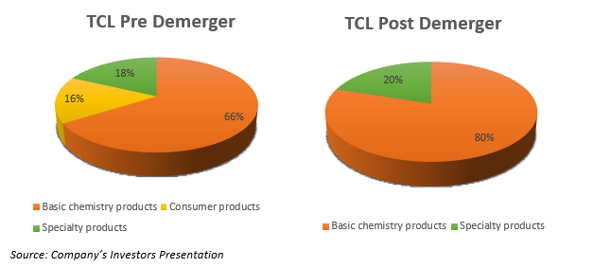

“The pie charts above shows the operating segments by revenue for TCL before and after the demerger Going on, the administration expects to quickly contribute and grow the Strength Item business (nourishing enhancements, silica, lithium particle batteries) and take the proportion to 50:50 while likewise plans to upgrade the Fundamental Science sections reach to expanded topographies. Set up Tata brands like Tata Salt, Tata Sampann and Goodbye NX which was essential for Buyer Item portion under TCL would now be converged with TCPL. The outlines underneath mirror the fragment shrewd proportionate portion of various brands under Tata Global Beverage Restricted both when the execution of consolidation.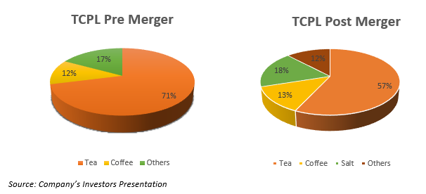

Turnover of demerged Buyer Item division as on March 31, 2019 was INR1,847 crore which comprised ~16% of the combined income TCL and ~18% (INR 314 Crores) commitment to working benefits. The table underneath shows the monetary effect of the exchange both pre and post demerger of TCPL (in the past Goodbye Worldwide Drink Restricted), displaying the expansion in income and EBITDA edge post-consolidation of shopper items section of TCL into Goodbye Worldwide Beverage Limited.

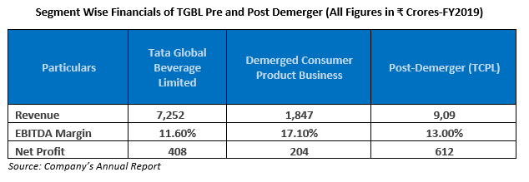

However, the demerger of the consumer product segment will have a subdued impact on both revenue and EBITDA margin of Tata Chemicals Limited as the demerged segment contributed the highest EBITDA margin of ~17% as on March 19. The impact of the same has been depicted in the table mentioned below which highlights the post demerger impact on the company (TCL).

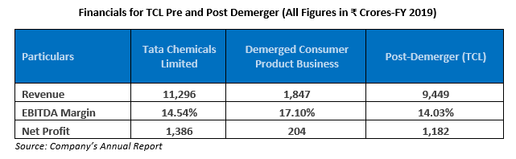

On a more drawn out term, however the arrangement demerges the high development customer section from TCL, it would help the association in concentrating just as sending assets to increase its substance portfolio towards high edge items. Furthermore, the rest of is decided to be a completely science focussed association, wherein the organization intends to grow its forte item business. The arrangement would likewise help the subsequent organization to extend its item portfolio in quick purchaser products classes both in India and abroad. Additionally, the consolidation of buyer item fragment in Tata Drinks would build the shopper impressions in India and abroad along these lines spreading the range to shifted families.

Debt Restructuring Case Examination:

Titan Organizations and Nirma got commitment rebuilding fully intent on paying off past responsibilities and improving financial backer worth .Inductions drawn from the relating between commitment esteem extent and ROCE of the two associations from 2.67 to 1.43, it will in general be seen that the contrasting ROCE extended from 16.75% with 29.86% – a prompt outcome of lessening financing cost .Then again, while Nirma diminished its inside and out low commitment esteem extent from 0.56 to 0.15, its ROCE broke down from 17.62% to 8.10%, which was not invaluable to the Association in view of operational weaknesses and extended tax assessment rates.

Subsequently paying off past commitments through money overflows isn't generally useful to the Company. Management's objective to emerge beneficial outcomes of obligation restructuring over a short to medium term period and henceforth a three to four-year time frame for the investigation is viewed as sensible.

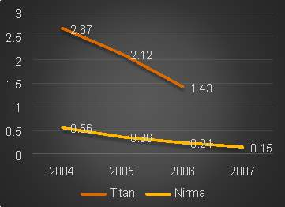

ROCE

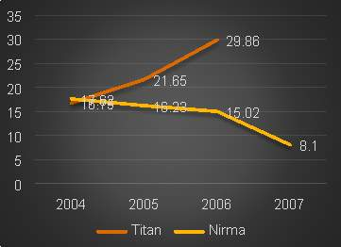

Debt Equity restructuring data

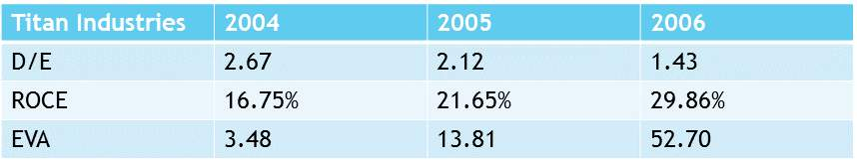

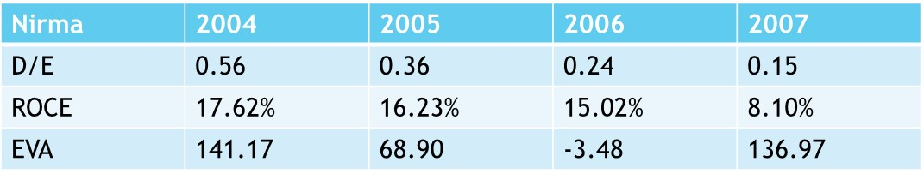

The particular company’s intention to personify the positive outcomes of debt restructuring over a short to medium period duration and hence a duration of a period of a few years for the analysis is considered to be good.

Share Buyback Case Investigation:

Bajaj Auto detailed buyback of parts of over Rs. 720 crores at a sensitive expense of Rs 400, the general market cost around then was simply Rs 376 for each offer and tended to a first class more than 6%. The middle inspiration driving the buyback as communicated by the organization was to give a nice exit to monetary patrons wanting to do, while at the same time guaranteeing the premium of the current financial backers. Regardless, the post buyback share cost of the Association was Rs. 360, which was even lower than the pre-buyback cost exhibiting financial backer bounty deterioration and a negative by and large return. The overall speed of return was a negative 2.7%.

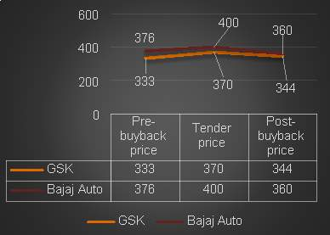

Essentially, in 2004, GSK reported an offer repurchase at an offer cost of Rs 370 for every offer. Around then the exchanged offer cost of the stock was Rs 333 for each offer and addressed a premium in abundance of 11%. The Board affirmed the over Rs 120 crores buyback on the expressed goal of boosting investor riches. The post buyback share cost of the Organization was Rs 344 for each offer, albeit much underneath the delicate cost, was as yet higher than its pre-buyback cost of Rs 333 for every offer. The general pace of return was a positive 3.85%.

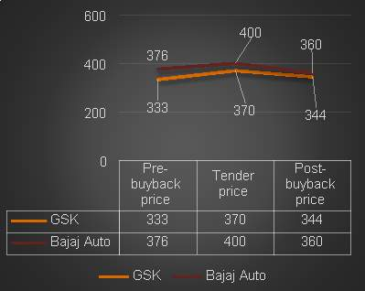

In spite of the fact that share buybacks have brought about investor esteem creation and defending of existing investors. The general pace of return has been low. By and large, post-buyback costs have been underneath the delicate cost and sometimes even beneath the pre-buyback cost, subsequently nullifying the point of fundamentally extending investor riches. Brought about huge surge of capital from the Organization for repurchasing just a little segment of the given capital. Addresses a helpless speculation decision and removes assets from aggressive, way breaking and high hazardous undertakings.

*Limitations of the examination*

1. The limitation of the study is the method of data collection. Secondary data is used in this case so the accuracy of the data may not be to the fullest. One more disadvantage can be the upgradation in technology is very fast. that is why the study may be limited to a particular time period.
2. Restructuring takes a few structures, anyway in our investigation we have covered just the three significant or generally utilized methods of capital restructuring viz. Demergers, obligation decrease and offer repurchase/buyback.
3. Likewise considering the lack of time to investigate, we have considered cases of just two organizations under each type of restructuring to show the impact of capital restructuring on investor esteem creation.

*Conclusion and Recommendations*

● If there should be an occurrence of Bajaj Auto, the total EVA post-demerger was much higher than the pre-solidification EVA of the single association, which suggested gigantic financial backer regard opening.

●In instance of Dabur India, negative joint efforts existed between the two associations, from this time forward the total EVA post-demerger was lesser than the pre-union composite EVA.

●In instance of demerger of TCL Post demerger, TCL is presently to a great extent a Science situated business with portfolio focussed on its Fundamental Science Items, Claim to fame Items and other related items like enormous dispersible silica, lithium battery and nourishing enhancements.

● if there should be an occurrence of consolidation of TCPL ,the expansion of this division to TCPL would synergise the general worth of TCPL both as far as income and commitments. This would additionally expand the geological expansion of TCPL and give admittance to more than 200 million families, more than 5,000,000 retail focuses making it one of the biggest buyer impressions in the country..

●:In case of Titan Industries it tends to be seen that debt restructuring is for the most part gainful to organizations with high obligation value ratio .As Titan viably paid off its obligation proportion from higher to lower which is advantageous to the organization.

● In case of Nirma we can say can that its D/E and ROCE got dropped which is quite disadvantageous to the organization.

● In case of both Bajaj Auto and GSK both their returns were negative. So it was not a good decision by the organization.

# 

# *References*

A.Deepika Dhingra, N. A. (2014). Corporate Restructuring in India : A case study of Reliance Industries Limited. *Global Journal of Finance and management* ,PP. 813-820.

*B.* Hiral Vyas , R K Patel. (2018/3). A study of Buyback of Shares as a restructuring tool : Reference to the Indian Companies Act. *Empyreal Institute of Higher Education* pp. 88-94.

C.Rakshit, D. and Ghosh, S. (2010): Demerger: Sailing with the global wind, NSHM Journal of Management Research and Application, Volume 2, Number 1, pp. 22-31.

D.Singh, R; Bhowal, A. and Bawari, V. (2009): Impact of Demerger on Shareholders’ Wealth, Enterprise Risk Management, Volume 1, Number 1, pp. 44-59.

E.Naman Sreen, Harsh Vardhan Somalia. (2017). *Impact of Organizational structure on Organizational performance: An Indian Perspective.* Journal of International Management Studies, Volume 17 , Issue 1

F.Deepika Kaur, Shashi Srivastava. (2017). Corporate Debt restructuring and firm performance: A study of Indian Firms. *Serbian Journal of Management* , 271-280.

G.Chatterjee, C., & Mukherjee, P. (2015). Price behaviour around share buyback in the Indian equity market. Global Business Review, 16(3), 425-438.

H. Jena, S., Mishra, C. S., & Rajib, P. (2017, September). Factors Influencing Share Buyback Decisions of Indian Companies. In 8th Conference on Financial Markets and Corporate Governance (FMCG).

I. Bao, H. (2017). Evaluation of pre and post Demerger-Merger performance: Using ABN AMRO Bank as an example. International Journal of Economics and Finance, 9(2), 196-204.

J. Dubey, A. K. (2016). A STUDY ON CONSUMER PERCEPTION WITH RESPECT TO DABUR HONEY.

K. Jaggi, B., & Lee, P. (2002). Earnings management response to debt covenant violations and debt restructuring. Journal of Accounting, Auditing & Finance, 17(4), 295-324.

L. Pâris, P., & Wyplosz, C. (2014). Politically Acceptable Debt Restructuring in the Eurozone. Geneva Special Report on the World Economy, 3.

M. Kim, W., Ko, Y., & Wang, S. F. (2019). Debt restructuring through equity issues. Journal of Banking & Finance, 106, 341-356.

N. Chen, X. (2017). Evaluation of Financial Position of the Company GlaxoSmithKline plc.

O. Ojha, A., & Bairagi, S. (2013). Corporate Restructuring. ABC Research Alert, 1(1), India-India.

P. Leepsa, N. M., & Singh, R. (2016). The Impact of Acquisition of an Insurance Company on Bank's Financial Performance: A Study on the Acquisition of Metlife India Insurance Co. Ltd. By Punjab National Bank. IUP Journal of Bank Management, 15(3), 52.

Q Evgeniou, T., de Fortuny, E., Nassuphis, N., & Vermaelen, T. (2016). Share Buyback and Equity Issue Anomalies Revisited.

*Bibliography*

●https://www.researchgate.net/publication/282787892_Corporate_Restructuring_in_India_with_Special_Reference_toReliance_Industries_Limited_RIL_Dinesh_N

● https://sauda.com/companion/pdf/cs/Professional/Sample%20Chapter/New%20Syllabus/Jul-15/Sample%20Chapter%20Solved%20Scanner%20CSPP%20Paper-3.

● http://www.aralaw.com/wp-content/uploads/2016/08/Corporate-Restructuring-Direct-Tax-ImplicationsLegal-Issues-In-Determining-Valuation-And-Exchange-RatioMAVenture-Funds-Sept-2001.

●:https//www.classic.ird.govt.nz/technical-tax/questions/questions-restruct/qwba-companyrestructuring.html

● https://www.taxmanagementindia.com/visitor/detail_manual.asp?ID=613

● www.legalservicesindia.com/article/420/Demerger-under-Company-Law.html

● https://theintactone.com/2019/07/26/tpm-u4-topic-6-merger-and-demerger-of-companies/

● https://home.kpmg/uk/en/home/services/audit/accounting-advisory/restructuring-and-group-simplifications.html

●https://www.lexisnexis.com/uk/lexispsl/corporate/synopsis/92510:99208/Demergers-and-restructuring/Demergers

● https://www.moneycontrol.com/financials/daburindia/cash-flowVI/di?classic=tru.